- Open Instagram's home page in Chrome, right-click on a post image, and use Inspect Element to find the exact HTML tag and CSS class used for the image container. Write down the tag name and class.
HTML Tag: Div
CSS Class: x1ey2m1c xtijo5x x1o0tod x10l6tqk x13vifvy

- Create a simple HTML file named myprofile.html that displays your name, a short bio, and a profile picture using appropriate HTML tags (h1, p, img). Open it in your browser and view the result.
<!DOCTYPE html>
<html lang="en">
<head>
<meta charset="UTF-8">
<meta name="viewport" content="width=device-width, initial-scale=1.0">
<title>My Profile</title>

<style>
body{
font-family: Arial, sans-serif;
background:#f4f4f4;
display:flex;
justify-content:center;
align-items:center;
height:100vh;
margin:0;
}

.profile{
background:#fff;
padding:30px;
border-radius:12px;
text-align:center;
box-shadow:0 5px 15px rgba(0,0,0,0.2);
max-width:350px;
}

img{
width:150px;
height:150px;
border-radius:50%;
object-fit:cover;
border:4px solid #007BFF;
}

h1{
margin:20px 0 10px;
color:#333;
}

p{
color:#666;
line-height:1.6;
}
</style>
</head>
<body>

<div class="profile">
<img src="/Gemini_Generated_Image_4v4hum4v4hum4v4h.png" alt="Profile Picture">

<h1>Ridham Dolera</h1>

<p>
Hello! I'm Ridham Dolera, a passionate web developer and
technology enthusiast. I enjoy building responsive websites,
learning new programming skills, and creating modern UI/UX
designs.
</p>
</div>

</body>
</html>

- Use Chrome DevTools to change the background color of your name (in myprofile.html) to any color you like, live in the browser, without editing the HTML file. 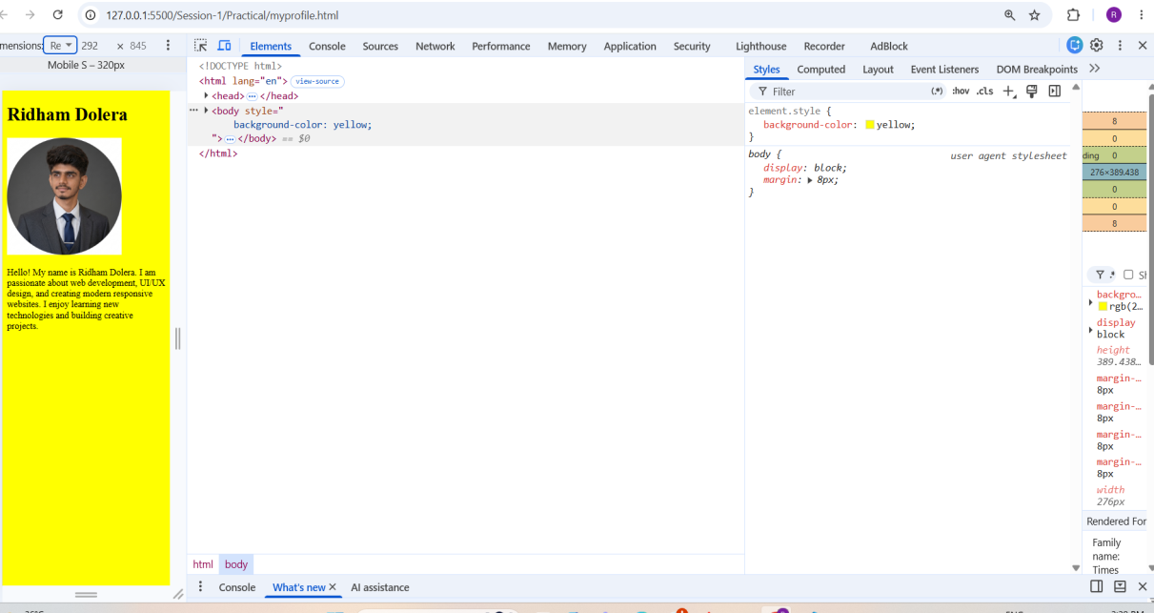

4. Draw a diagram or write a list showing the DOM structure (parent-child relationships) of your myprofile.html page. Include at least 3 levels (html > body > your content).

Parent → Child Relationships
- html
  - head
    - title
  - body
    - h1
    - img
    - p
This diagram includes at least 3 levels:
- html
- body

